LABORATORY REPORT

Active Directory
and Kerberos
  - Domain implementation and analysis
of privilege relationships
Windows Server 2019 · BadBlood · SharpHound
BloodHound Community Edition · Neo4j

Exercise 1
Attacks on Active Directory and Kerberos
16 October 2026

Abstract
This laboratory report documents the configuration of an Active Directory domain on Windows Server 2019 and the analysis of its privilege relationships. The evidence confirms the lab.local domain, the DC01 domain controller, data collection with SharpHound and object visualisation in BloodHound Community Edition. The use of BadBlood is accompanied by object counts showing the growth of the directory.
The clearest path links Administrator to the Domain Admins and Enterprise Admins groups and, through their AdminTo relationships, to DC01. This result supports a discussion of the impact of a compromised privileged identity. It does not demonstrate privilege escalation from a standard user account or a completed Kerberos exploit.
Keywords: Active Directory; Kerberos; access control; BloodHound; attack path analysis.

Contents
1 Introduction and background 3
2 Laboratory environment 4
3 Server network configuration 5
4 Communication with the Linux workstation 6
5 Directory service installation 7
6 Forest and domain creation 8
7 Domain controller validation 9
8 Environment generation with BadBlood 10
9 Changes in domain object counts 11
10 Data collection with SharpHound 12
11 Running BloodHound Community Edition 13
12 Neo4j configuration and access 14
13 Data import and exploration 15
14 Domain properties in BloodHound 16
15 Administrator account memberships 17
16 Privilege path to DC01 18
17 Scope of the Domain Admins group 19
18 Attack vector analysis 20
19 Risks and mitigation measures 21
20 Results against the exercise requirements 22
21 Conclusion 23
22 References 24

1 Introduction and background
The exercise builds an Active Directory environment and examines how relationships between users, groups, computers and permissions can form potential attack paths. The work proceeds from directory-service deployment to test-object generation, data collection and interpretation of the resulting privilege graph.

Active Directory and access control
Active Directory Domain Services, or AD DS, organises identities and resources within a domain. The domain controller maintains the directory and supports authentication and policy enforcement. Groups assign rights to multiple members, while access control lists, or ACLs, specify permissions on objects. A legitimate membership can become part of an attack path if the source identity is compromised [1, 5, 6].

Kerberos in the domain
Kerberos uses a Key Distribution Center, or KDC, which runs on the domain controller in Windows. After initial authentication, the client obtains a ticket granting ticket, or TGT. This ticket allows the client to request tickets for specific services without presenting the password to each service again [1].
Ticket issuance supports authentication, while group memberships and permissions determine authorised access. A privilege graph helps assess an account's potential reach, but does not by itself prove that Kerberos tickets have been captured, reused or forged.

Analysis method
The analysis follows the exercise requirements and links observations to the relevant figures. Directly visible results are distinguished from exploitation hypotheses and proposed validation steps. Screenshots are labelled C01–C44: C01 is the file without a numerical suffix, while C02–C44 correspond to suffixes 1–43. Cropped screenshots retain the relevant window content and are identified in their captions.
Additional screenshots show the preparation of a Windows 11 VM named CLIENTE01. A Linux configuration named CLIENT01 appears in the networking and BloodHound deployment stages. These are treated as separate records, without assuming they represent the same operating system or that a Windows client was joined to the domain.

2 Laboratory environment
DC01 runs Windows Server 2019 Standard Evaluation in a VirtualBox virtual machine. Figure 1 identifies the edition, 8 GB of memory and 59.46 GB of total disk space. The DC01 hostname is also confirmed by running hostname.
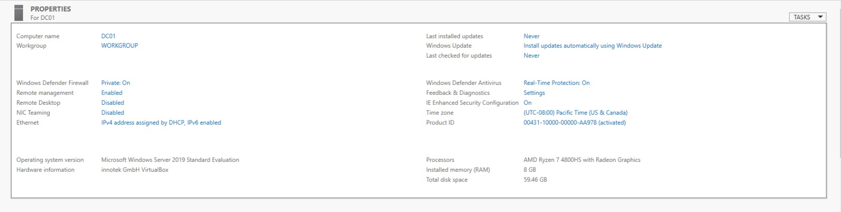
Figure 1 — DC01 server properties and virtual machine resources. Source: screenshot C15.
Component | Observed configuration
Domain controller | DC01.lab.local; Windows Server 2019 Standard Evaluation
Domain and forest | lab.local; NetBIOS name LAB
Internal network | LAB; address range 192.168.10.0/24
DC01 internal interface | 192.168.10.10; preferred DNS 192.168.10.10
DC01 NAT interface | 10.0.2.15; gateway 10.0.2.2
Linux workstation CLIENT01 | Configured IPv4 192.168.10.20/24; DNS 192.168.10.10
Analysis tools | BadBlood; SharpHound 2.17.0.0; BloodHound CE 9.8.0
Data persistence | Neo4j container and Neo4j Desktop 1.6.3 records
The server adapters include a NAT connection and a connection to the LAB internal network. This configuration supports the observed external access and laboratory network communication, although it does not prove complete isolation.

System updates
The exercise requires all updates to be installed. In the state recorded in Figure 1, the last installed updates and last checked for updates fields both show Never. The operating system installation is demonstrated; installation of all patches is not validated. Completing this stage requires Windows Update history or an update inventory together with a check for pending updates.

3 Server network configuration
The Ethernet 2 interface uses the static address 192.168.10.10 and subnet mask 255.255.255.0. The preferred DNS server points to the server itself. The absence of a gateway on this interface is consistent with a separate interface providing external access.
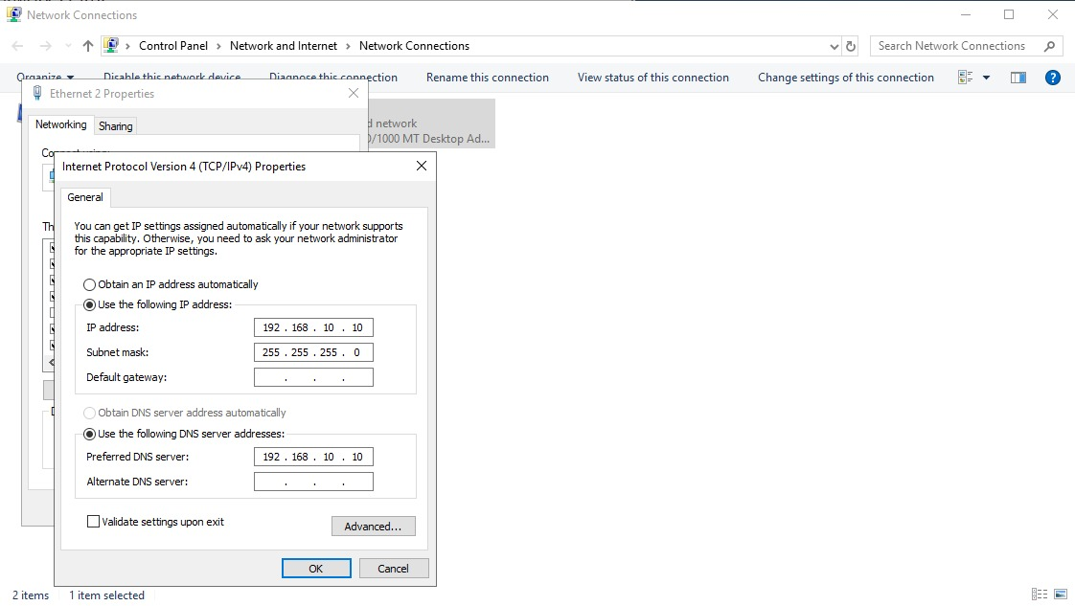
Figure 2 — Static addressing and DNS on the DC01 internal interface. Source: screenshot C12.
The output of ipconfig /all confirms both interfaces: Ethernet using DHCP on the NAT network and Ethernet 2 configured manually on the laboratory network.
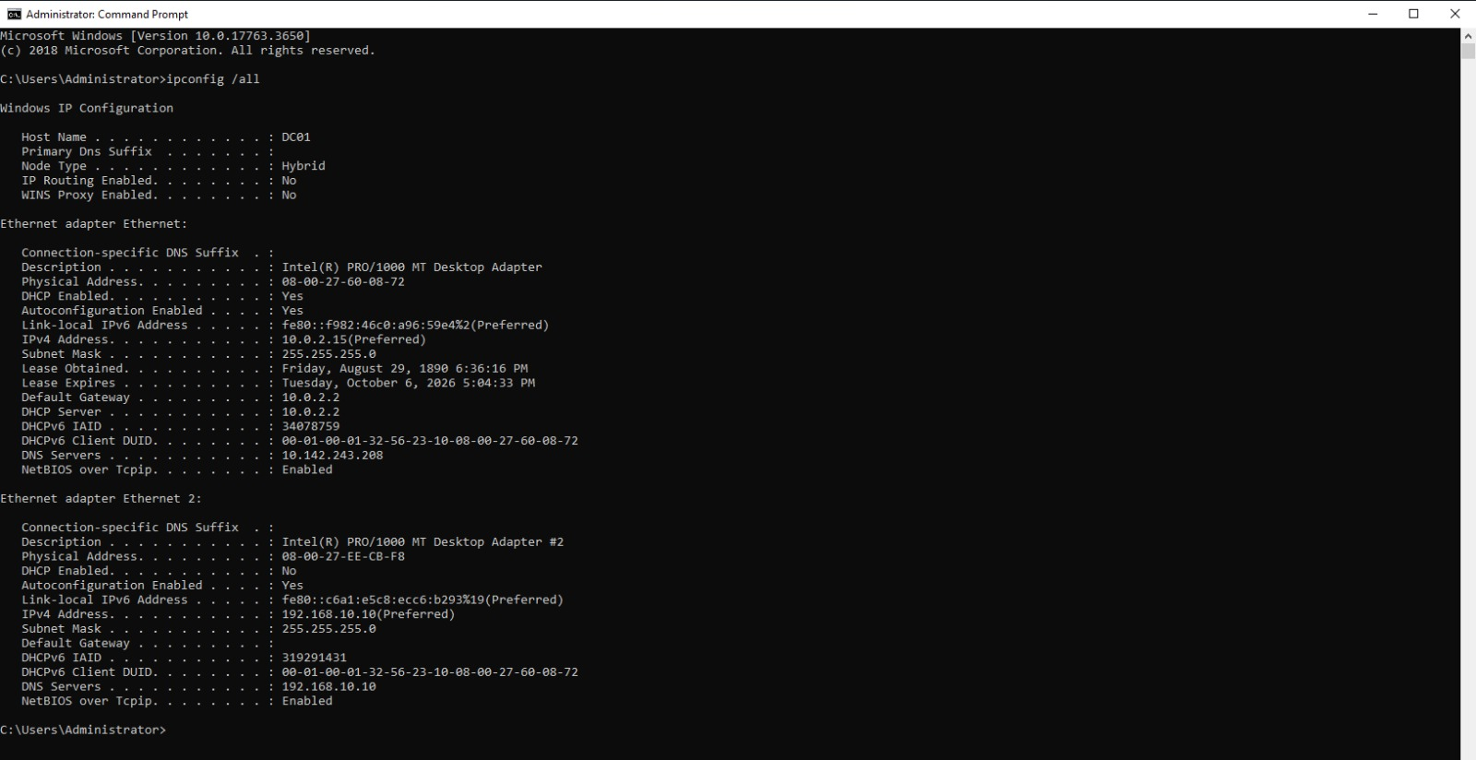
Figure 3 — NAT and internal interface settings shown by ipconfig. Source: screenshot C11.

4 Communication with the Linux workstation
The Linux workstation's graphical configuration shows 192.168.10.20/24 and DNS server 192.168.10.10. The following tests check IP communication with DC01 and resolution of the domain name.
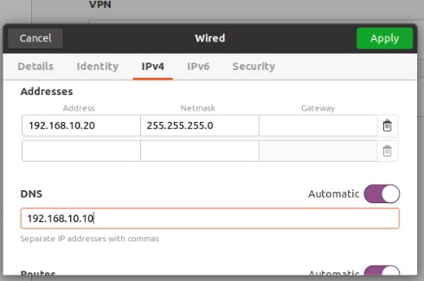
Figure 4 — IPv4 configuration and DNS server on the Linux workstation. Source: screenshot C27 cropped.
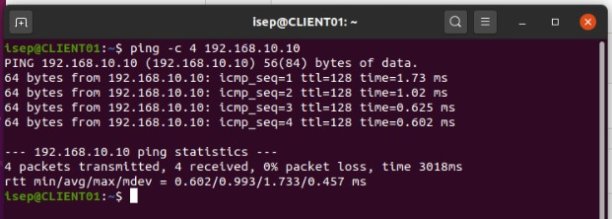
Figure 5 — Four replies from DC01 with zero per cent packet loss. Source: screenshot C26 cropped.
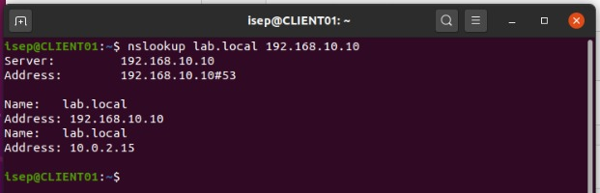
Figure 6 — Resolution of lab.local through the DC01 DNS server. Source: screenshot C25 cropped.
The command `nslookup lab.local 192.168.10.10` returns both 192.168.10.10 and 10.0.2.15. The latter is the server's NAT-interface address and should be reviewed in DNS: clients on the internal network should resolve names to addresses they can reach. The successful ping test confirms IP connectivity only; it does not validate domain authentication.

5 Directory service installation
In the Add Roles and Features wizard, the Active Directory Domain Services role was selected for DC01. Installing the role prepares the server, but creating the domain requires the subsequent promotion stage.
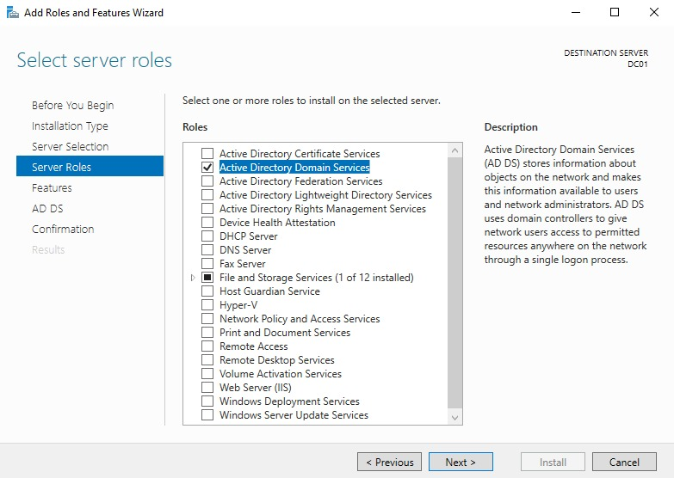
Figure 7 — Selection of the Active Directory Domain Services role. Source: screenshot C03.
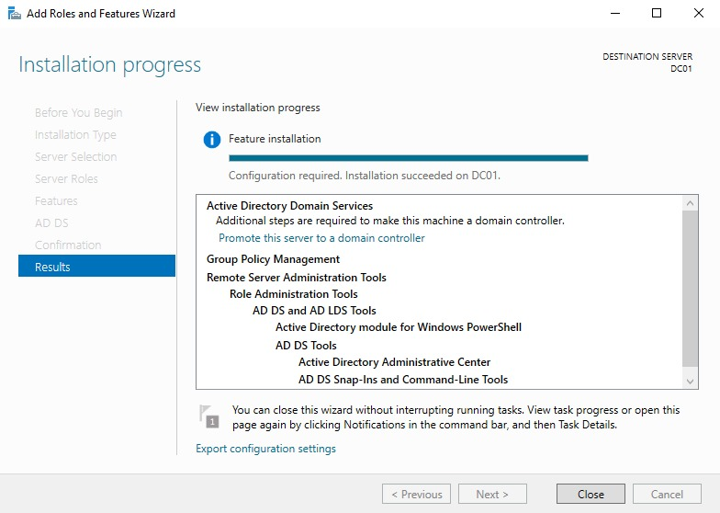
Figure 8 — AD DS installation completed with additional configuration required. Source: screenshot C04.

6 Forest and domain creation
The promotion wizard selects Add a new forest and sets lab.local as the root domain. The following options configure Windows Server 2016 functional levels and enable DNS and Global Catalog.
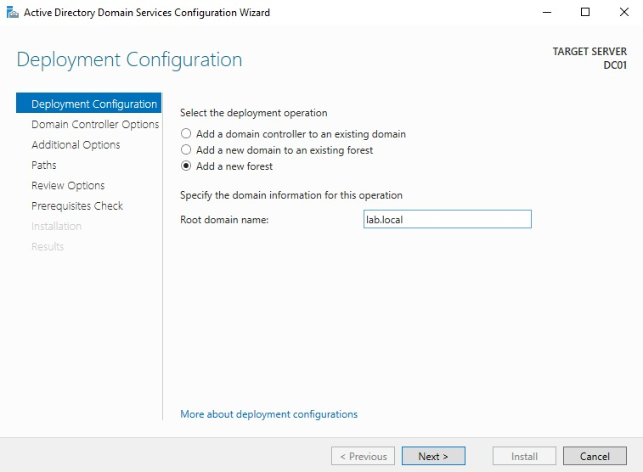
Figure 9 — Creation of a new forest with the lab.local domain. Source: screenshot C05.
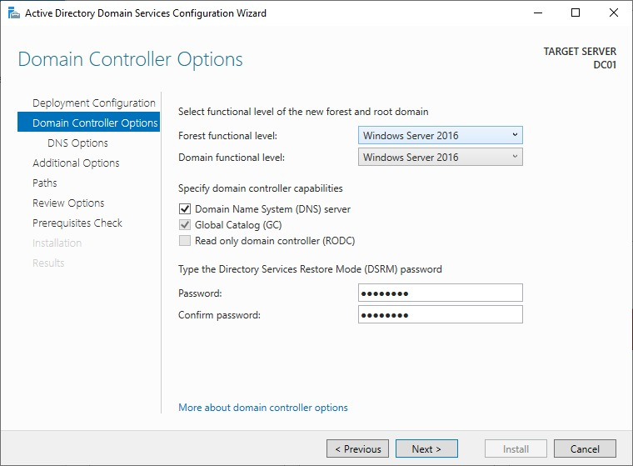
Figure 10 — Functional levels and DNS and Global Catalog options. Source: screenshot C07.
The 2016 functional level is a domain and forest setting; the installed operating system remains Windows Server 2019. The DSRM recovery password is masked and is not reproduced in this report.

7 Domain controller validation
The Get-ADDomainController query identifies DC01.lab.local, the address 192.168.10.10, the global catalogue and the writable controller status. The OperationMasterRoles property lists the FSMO roles.
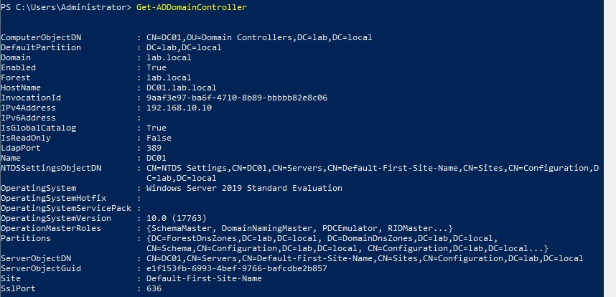
Figure 11 — DC01 identified as the domain controller and FSMO role holder. Source: screenshot C42.
The Get-ADDomain query confirms DNSRoot lab.local, NetBIOSName LAB and DomainMode Windows2016Domain. Together, these results support the server's promotion and the existence of the domain.
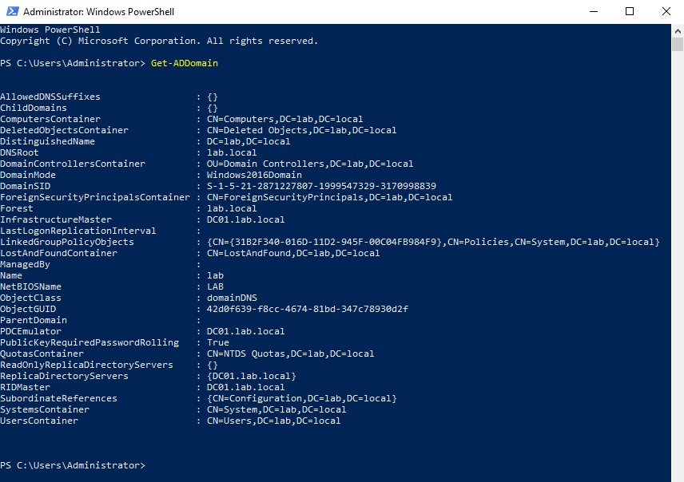
Figure 12 — Domain properties obtained using `Get-ADDomain`. Source: screenshot C43.

8 Environment generation with BadBlood
BadBlood generates users, groups, computers, organisational units and permissions for Active Directory training [2]. The initial inventory shows 3 users, 48 groups, 1 computer and 1 organisational unit.
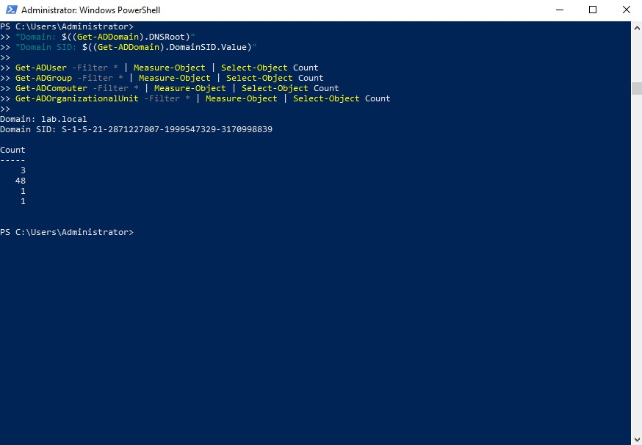
Figure 13 — Domain identification and initial object counts. Source: screenshot C39.
The BadBlood startup screen shows parameters of 100 users, 30 groups and 10 computers. This screen documents the requested values and awaits execution confirmation; it is not a final count.
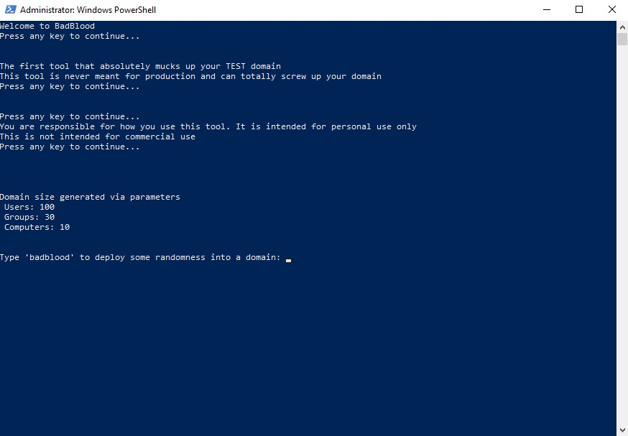
Figure 14 — BadBlood parameters displayed before confirmation. Source: screenshot C38.

9 Changes in domain object counts
A later record shows 93 users, 77 groups, 10 computers and 223 organisational units. The same screenshot shows the DNS and NTDS services in the Running state.
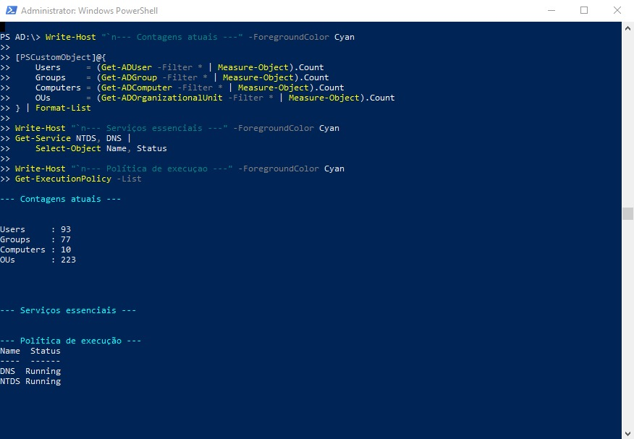
Figure 15 — Later object counts and essential service status. Source: screenshot C37.
Object type | Initial state | Later state | Change
Users | 3 | 93 | +90
Groups | 48 | 77 | +29
Computers | 1 | 10 | +9
Organisational units | 1 | 223 | +222
These differences compare two observed inventories; they should not be interpreted as the number of objects created by a single BadBlood run. In particular, the later total of 93 users does not confirm that all 100 users specified in the parameters were created.
The increase in objects and relationships is consistent with the preparation of a more complex training environment. Full execution validation would require the BadBlood completion log and a review of any errors. The 223 organisational units also expand the surface on which delegated and inherited permissions may exist.

10 Data collection with SharpHound
The observed command is .\SharpHound.exe --CollectionMethods Default, run from C:\Lab\SharpHound. The collector identifies lab.local and completes enumeration. One collection records 301 objects processed and another 651; these figures describe separate runs and do not replace directory object counts.
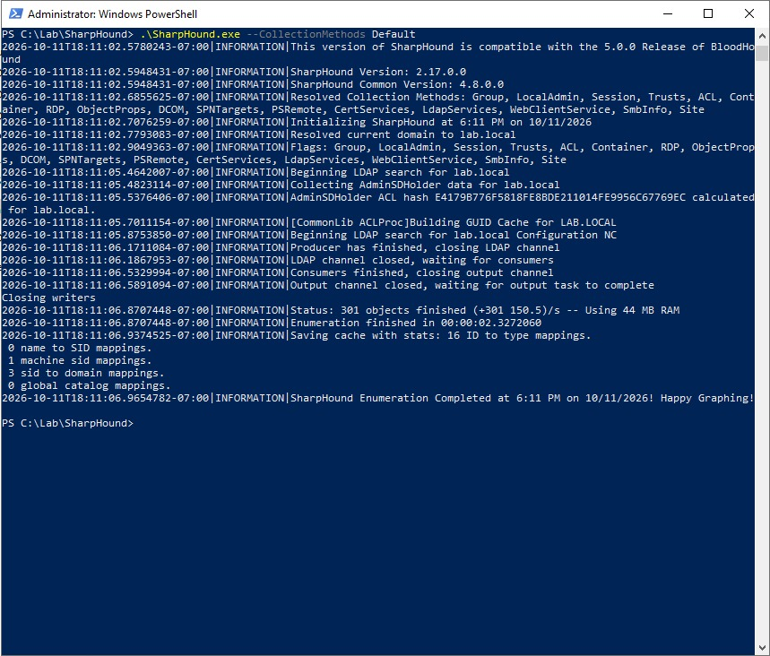
Figure 16 — First completed collection with 301 objects processed. Source: screenshot C09.
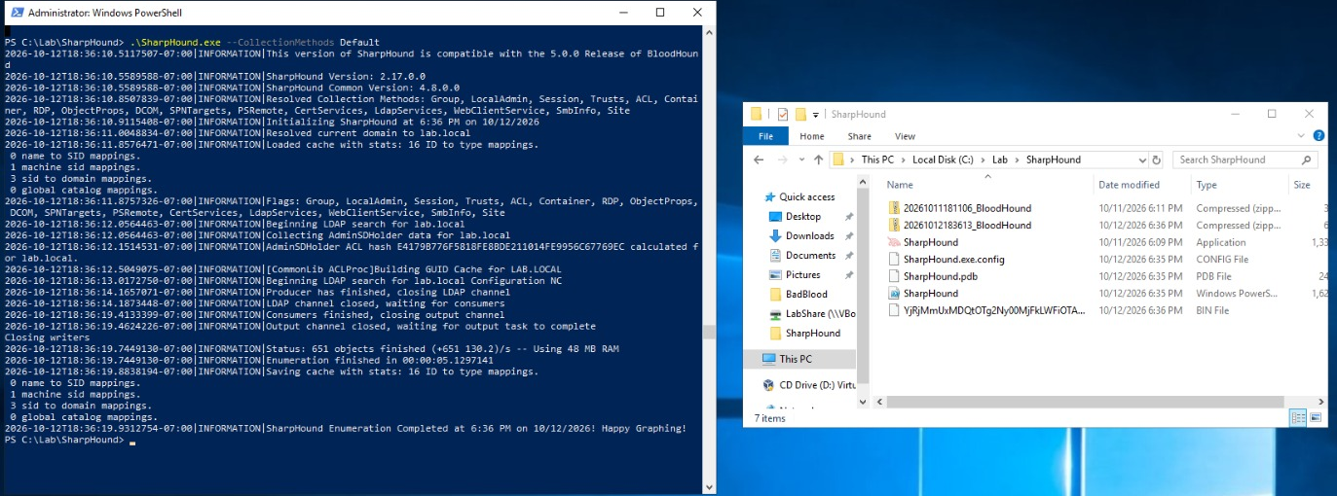
Figure 17 — Later collection with 651 objects and ZIP output files. Source: screenshot C31 cropped.
The methods listed in the log include groups, local administration, sessions, trusts, ACLs and object properties. Creation of a ZIP demonstrates that a collection package was produced; its availability in BloodHound is validated in the following stages.

11 Running BloodHound Community Edition
The Linux workstation shows Docker 26.1.3 and Docker Compose 2.27.1. Running sudo docker compose up -d creates the volumes and starts the application, application database and graph database services [3].
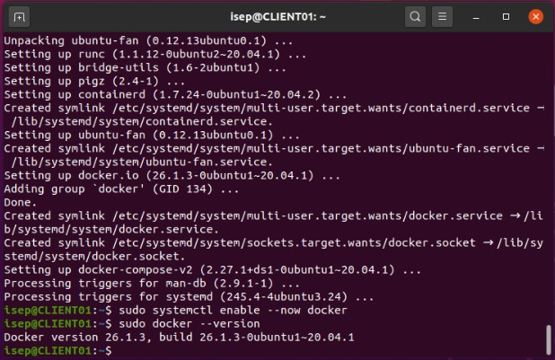
Figure 18 — Docker installation and verification on the Linux workstation. Source: screenshot C24 cropped.
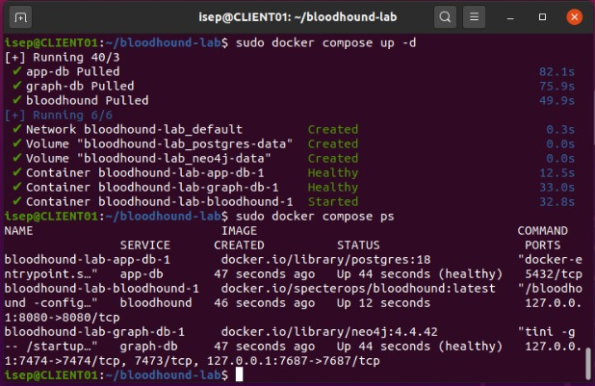
Figure 19 — Service startup and status checks with Docker Compose. Source: screenshot C22 cropped.
The docker compose ps output shows app-db and graph-db as healthy and the bloodhound service running. The visible graph database image is neo4j:4.4.42. Application access is published on 127.0.0.1:8080 and Neo4j services on 127.0.0.1:7474 and 127.0.0.1:7687.

12 Neo4j configuration and access
The records include Neo4j Desktop 1.6.3, a form for creating BloodHound-Lab with version 4.4.0 and a Neo4j Browser session connected through Bolt to localhost:7688. These observations confirm the use of Neo4j tools [4].
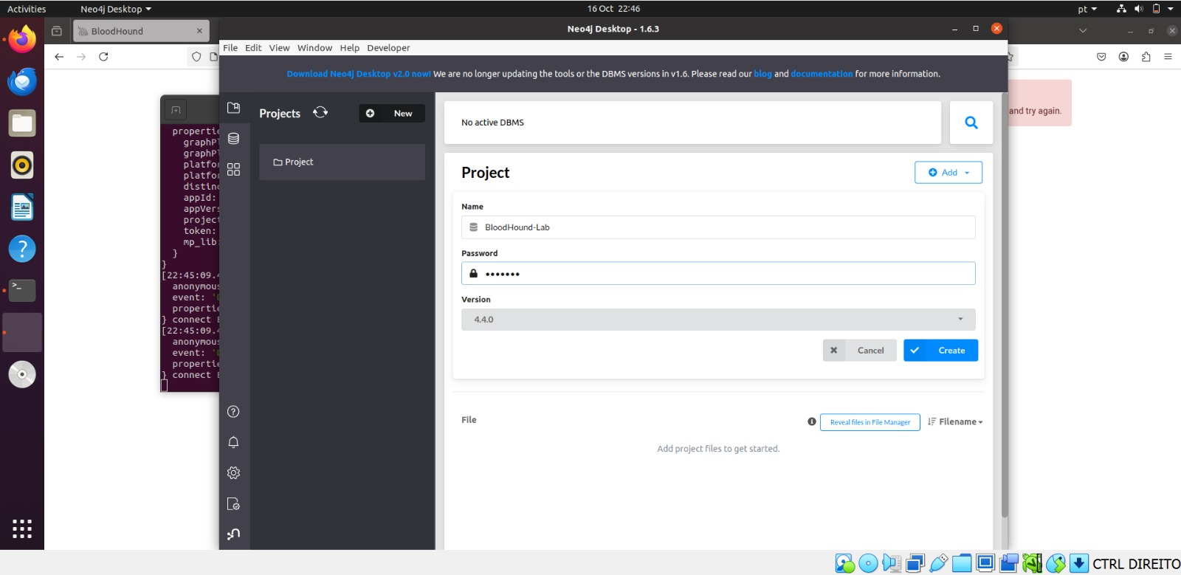
Figure 20 — BloodHound Lab creation form in Neo4j Desktop. Source: screenshot C19.
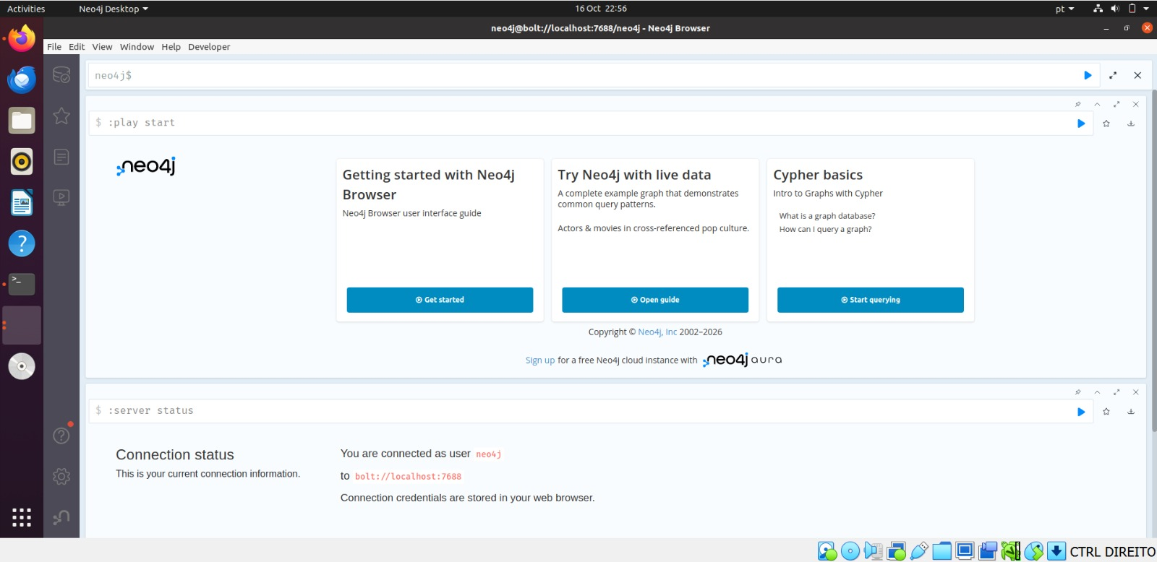
Figure 21 — Neo4j Browser session connected as user neo4j. Source: screenshot C17.
Port 7688 in this session differs from port 7687 published by the graph-db container. It cannot be concluded that the Desktop project is the database actually used by BloodHound CE. Results being loaded are demonstrated in BloodHound through the upload and the objects subsequently queried.

13 Data import and exploration
Quick Upload accepts JSON and ZIP files containing collector results. The following figure shows the 20261011181106_BloodHound.zip package at 100 per cent and a message confirming successful upload for ingestion.
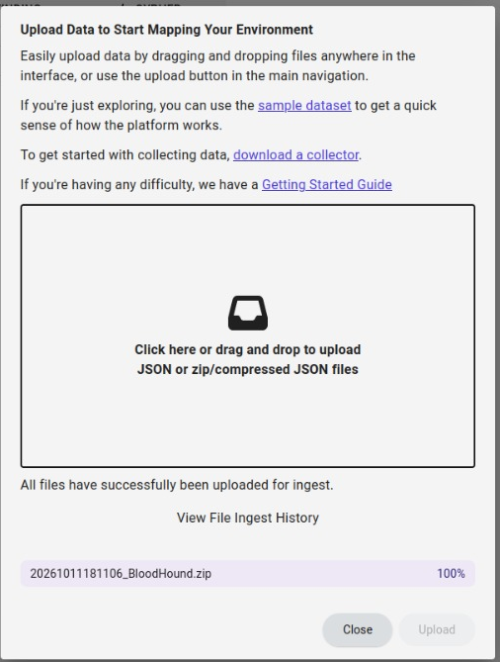
Figure 22 — SharpHound package uploaded for ingestion in BloodHound CE. Source: screenshot C35 cropped.
A completed upload alone does not prove that ingestion has finished. The subsequent queries of the LAB.LOCAL domain and Administrator relationships provide evidence that Active Directory data is available for graph analysis.
The uploaded ZIP filename corresponds to the collection reporting 301 objects processed. A later collection processed 651 objects, but the screenshots do not unambiguously identify the import of that second package. Graph counters are therefore not automatically equated with the later BadBlood inventory.

Reading the following figures
The following pages use landscape orientation to keep node names, relationship labels and BloodHound properties legible. The MemberOf and AdminTo labels are retained for direct comparison with the tool.

14 Domain properties in BloodHound
The LAB.LOCAL node is collected and classified in the Tier Zero zone. The panel shows functional level 2016, Machine Account Quota of 10 and Lockout Threshold of 0. These values describe the collected state and justify reviewing computer account creation and lockout policies.
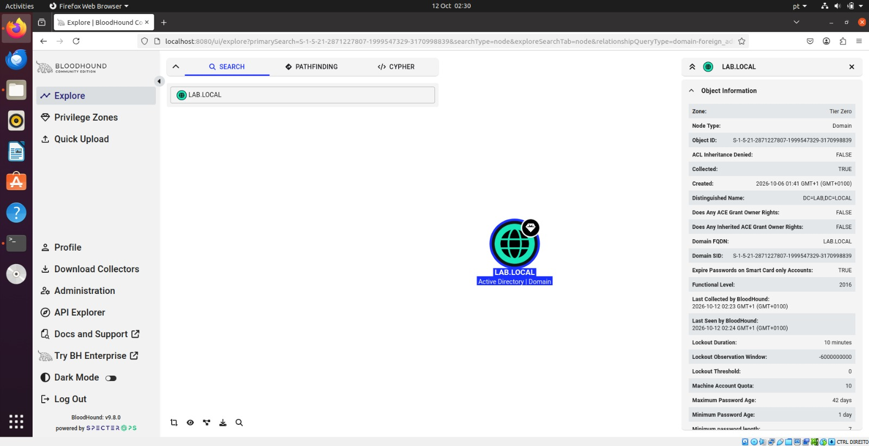
Figure 23 — Properties of the LAB LOCAL node in BloodHound. Source: screenshot C34.

15 Administrator account memberships
The Member Of query displays 11 memberships in the interface, including Domain Admins, Enterprise Admins and Schema Admins. MemberOf indicates group membership; the relationship alone does not demonstrate a vulnerability. Group rights explain the account's administrative reach [5].
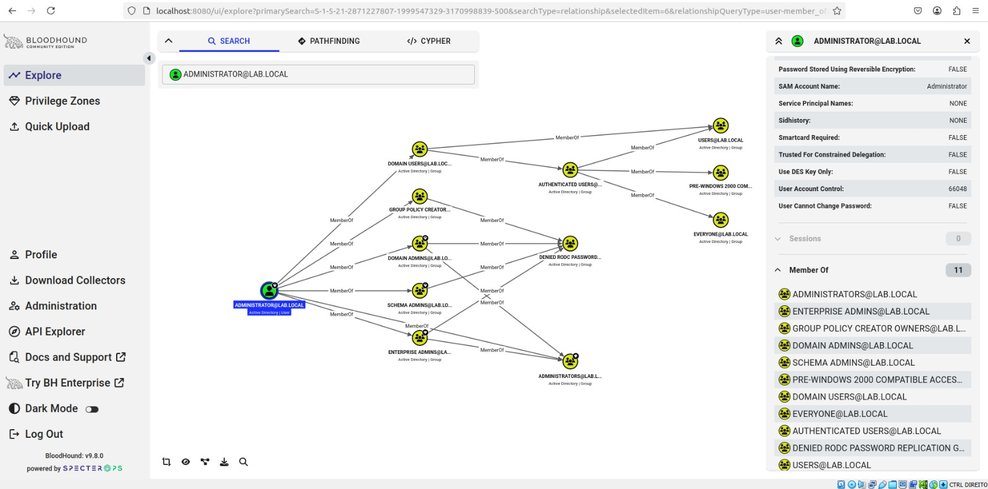
Figure 24 — Administrator memberships and group nesting. Source: screenshot C33.

16 Privilege path to DC01
The following figure shows two paths: Administrator → MemberOf → Domain Admins → AdminTo → DC01 and Administrator → MemberOf → Enterprise Admins → AdminTo → DC01. AdminTo represents administrative rights on the target computer [6]. The path assumes control of Administrator and does not demonstrate escalation from a standard account.
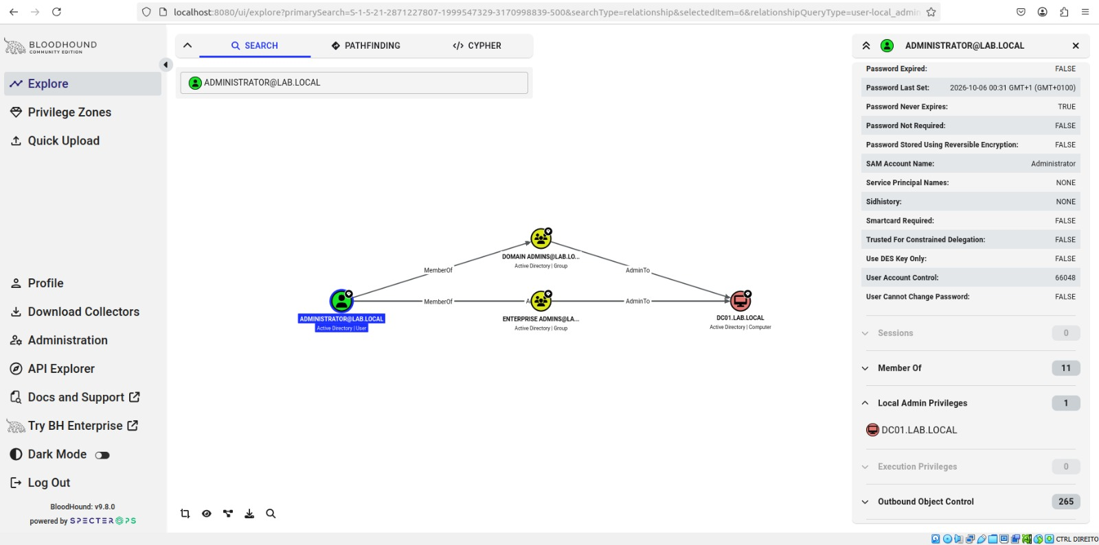
Figure 25 — Paths from Administrator to administrative control of DC01. Source: screenshot C32.

17 Scope of the Domain Admins group
The Domain Admins panel shows 1 member, local administrative privileges on 1 computer, 3 inbound object control relationships and 614 outbound relationships. The graph includes Owns and WriteOwner over several objects. The counters do not represent 614 independent vulnerabilities or demonstrate that a standard user can control this group.
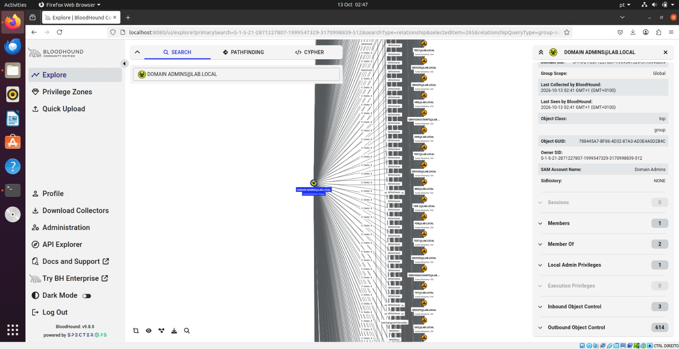
Figure 26 — Domain Admins group relationships and counters. Source: screenshot C36.

18 Attack vector analysis

Observed path and starting condition
The graph supports analysis of a scenario in which an identity that already has domain-administrative privileges is compromised. The assumed starting condition is control of the Administrator account. This is a scenario for impact analysis, not a demonstrated event: the evidence does not show password recovery, ticket acquisition or session takeover.
Once this identity is controlled, MemberOf relationships link it to Domain Admins and Enterprise Admins. AdminTo relationships connect those groups to DC01. The potential impact is use of existing administrative rights over the domain controller, subject to authentication, connectivity, available services and system controls [5, 6].

Potential exploitation in a test environment
Validating this scenario in a laboratory would require authenticating a test session as the source identity, confirming effective group memberships and verifying a limited administrative operation on the target, while preserving authentication logs and the operation's result. Remote administrative access could realise the path if the corresponding service were enabled and reachable. The initial server screenshot shows Remote Desktop as Disabled, so RDP access cannot be assumed.
HackTricks describes Active Directory relationship analysis and permission abuse as areas of investigation [7]. In this case, further escalation analysis would need to start from an unprivileged user and identify a verifiable chain to a sensitive object. The outbound relationships of Domain Admins do not provide that starting condition.

Relationship with Kerberos
Kerberos can authenticate a session of the compromised identity using tickets issued by the KDC. However, the figures do not include tickets, the SPN of an attacked service account, captured TGS requests, password recovery material or exploitation results. Execution of Kerberoasting, AS REP roasting, Pass the Ticket or Golden Ticket cannot be concluded. The demonstrated result is analysis of authorisation and privilege reach.

Evidence required to complete validation
Confirming an attack would require linking the starting identity, each relationship in the path, the action performed and the resulting change or access. Escalation from a standard account would also require proof of the inappropriate permission that allows privilege boundaries to be crossed. Without this link, the appropriate classification is a potential path with high impact and no demonstrated exploitation.

19 Risks and mitigation measures
The following recommendations arise from the observed configurations and path analysis. They are proposed measures, rather than changes already implemented or results of a new test.
Observation | Implication | Proposed measure
Administrator belongs to domain administration groups | Account compromise may provide administrative access to DC01. | Separate administrative and everyday accounts; restrict sign-in locations and review privileged memberships.
Password Never Expires is TRUE for Administrator | An exposed credential may remain valid for longer. | Review account policy, enforce strong passwords and manage rotation in line with administrative use.
Lockout Threshold is 0 on the domain node | The collected policy does not define lockout after failed attempts. | Define an appropriate policy and monitor authentication failures, considering the risk of malicious lockouts.
Machine Account Quota is 10 | Review who can create computer accounts and under which conditions. | Restrict computer creation to authorised identities and audit new accounts.
Multiple Owns and WriteOwner relationships | Inappropriate delegation may extend an identity's reach. | Review ACLs and owners from low-privilege accounts; remove unnecessary delegation.
DNS for lab.local also returns 10.0.2.15 | Internal network clients may receive an address without a suitable route. | Review DNS registration on the NAT interface and validate names and services from the LAB segment.
Updates not evidenced | The requirement to install all patches has not been validated. | Complete updates, restart if needed and retain the history and final status.
After each correction, collection should be repeated and the path compared in BloodHound, also checking in Active Directory whether effective permissions have changed. A visual graph change is meaningful only when the data reflects the current directory state.

20 Results against the exercise requirements
Requirement | Evidence and assessment
1 Obtain Windows Server 2019 | Windows Server 2019 Standard Evaluation is running. The image source and download process are not demonstrated.
2 Install on a virtual machine | VirtualBox is identified in system properties. Server installation and operation are demonstrated.
3 Install all patches | Not validated. The initial record shows Never in the update fields.
4 Promote to Domain Controller | Demonstrated by the wizards, Get-ADDomainController and Get-ADDomain.
5 Use BadBlood | Startup, parameters and object growth are demonstrated. Full completion of a run is not confirmed by a final log.
6 Run BloodHound | Demonstrated by service startup, the CE 9.8.0 interface and graph queries.
7 Install Neo4j Desktop and load results | Desktop and Browser are demonstrated. ZIP upload and object queries show data in BloodHound. It is not established that the Desktop instance is the application's database.
8 Identify a vector and discuss exploitation | Administrator → privileged groups → DC01 path identified. Exploitation is discussed as a hypothesis; escalation from a standard account and a Kerberos attack are not demonstrated.

Experimental limitations
The records represent different environment states. The imported ZIP is identifiable, but there is no complete history linking all counts, collections and queries to the same run. Machine clocks and time zones also vary, so filename order is not used as an experimental chronology.
Creation of a Windows 11 VM is a preparation record, not proof of domain membership. Similarly, the LAB\Administrator screen confirms the displayed sign-in context, but does not demonstrate an attack or replace a record of successful authentication.

21 Conclusion
The exercise documented an Active Directory domain on Windows Server 2019, with DC01 providing domain and DNS services for lab.local. Network settings, administrative queries and service status support the operation of the main laboratory components.
BadBlood records and subsequent counts show directory expansion. SharpHound produced collection packages, and BloodHound CE displayed the domain and its privilege relationships. The analysis made explicit the path from Administrator to administrative control of DC01 through Domain Admins and Enterprise Admins.
The main security outcome is a clearer view of the impact that compromise of a privileged account could have. The observed path reflects existing administrative rights rather than a demonstrated escalation. To establish privilege escalation, the analysis would need to begin with a less-privileged account and identify a verifiable permission that crosses a security boundary. A Kerberos attack would require additional evidence specific to the tickets and technique involved.
Completing laboratory validation requires evidence of updates, a DNS registration review and a link between each collection and the domain state. Security priorities are to reduce privileged identity exposure, review delegation and repeat the analysis after corrections.

Summary of confirmed results
Result | Observed value
Domain | lab.local
Controller | DC01.lab.local at 192.168.10.10
Domain functional level | Windows Server 2016
Objects in the later inventory | 93 users; 77 groups; 10 computers; 223 organisational units
Essential services | DNS and NTDS running
SharpHound collections | 301 and 651 objects processed in separate runs
Privilege path | Administrator → Domain Admins or Enterprise Admins → DC01
Completed exploitation | Not demonstrated

22 References
Technical sources accessed on 16 October 2026. The references explain concepts and tool interpretation; experimental results are documented in the laboratory figures.
[1] Microsoft. Kerberos authentication overview in Windows Server.
https://learn.microsoft.com/en-us/windows-server/security/kerberos/kerberos-authentication-overview
[2] Rowe, D. BadBlood. Project repository and documentation.
https://github.com/davidprowe/BadBlood
[3] SpecterOps. BloodHound Community Edition Custom Installation.
https://bloodhound.specterops.io/get-started/custom-installation
[4] Neo4j. Connect to a Neo4j DBMS. Neo4j Browser.
https://neo4j.com/docs/browser/legacy/operations/dbms-connection/
[5] SpecterOps. MemberOf. BloodHound Edges.
https://bloodhound.specterops.io/resources/edges/member-of
[6] SpecterOps. AdminTo. BloodHound Edges.
https://bloodhound.specterops.io/resources/edges/admin-to
[7] HackTricks. Active Directory Methodology.
https://book.hacktricks.wiki/es/windows-hardening/active-directory-methodology/index.html
Exercise source: Exercise 1 Attacks on Active Directory Kerberos, exercise sheet image. Figure sources: laboratory screenshots identified in their respective captions.

